A Project Report

ON

SCNF | Secure Campus Network Framework

BY

**Student Name:** SHIVAM SWARAJ **Roll No:** 23CA2591054

**Program Name:** BCA (CYBERSECURITY) **Semester:** 5th

**Group Project:** NO **Group Code:** SS



APEX UNIVERSITY, JAIPUR

(DEC. 2025)

Table of Content

| **S. No.** | **Title** |
| --- | --- |
| 1 | Abstract |
| 2 | Introduction |
| 3 | Objectives of the Project |
| 4 | Scope of the Project |
| 5 | Campus Structure and Network Planning |
| 6 | Network Design and Topology |
| 7 | VLAN Configuration and IP Addressing |
| 8 | DHCP Configuration and Implementation |
| 9 | Inter-VLAN Routing (Router-on-a-Stick) |
| 10 | Security Implementation (ACL / Firewall) |
| 11 | Ethical Hacking Simulation and Analysis |
| 12 | Application of (SPM) in SCNF Project |
| 13 | IT ACT |
| 14 | Conclusion |
| 15 | Future Enhancements |

Abstract

Universities today deal with serious cybersecurity threats. With everyone relying on computers and the internet, risks just keep growing. The Secure Campus Network Framework (SCNF) project tackles this challenge head-on. Its goal? Build a campus network that’s not just secure, but also flexible and easy to manage.

Here’s how the project works: it splits the network into logical segments using VLANs. This way, Admin, Faculty, Students, and Server rooms each get their own secure space. No more messy overlap. DHCP handles IP addresses automatically, which cuts down on mistakes and saves time. For communication between these groups, the team uses the Router-on-a-Stick method. This keeps things organized and lets departments talk to each other—but only when it’s needed.

Security isn’t an afterthought. Access Control Lists (ACLs) block unauthorized users from crossing into areas they don’t belong. To really put the system to the test, the team runs an ethical hacking simulation. Using Kali Linux tools—Nmap, Nikto, Metasploit, and Wireshark—they dig into the network’s weak spots and study possible attack routes. They don’t just stop at finding problems; they map these issues back to the campus network and recommend targeted security fixes.

The big takeaway? Segmenting the network, automating tasks, and keeping a close eye on security policies matter a lot. The SCNF project gives universities a real-world blueprint for building safer, smarter networks.

Introduction

Campus networks keep everything running—classes, admin stuff, even day-to-day communication. They handle a ton of sensitive data: student records, staff info, all the critical resources. So, security isn’t just important—it’s non-negotiable. That’s why we kicked off the Secure Campus Network Framework (SCNF) project. The main goal? Build a campus network that’s not just secure, but also organized and ready to grow, using what we’ve learned in different tech courses.

We pulled in ideas from Ethical Hacking, Advanced CTP Cyber Security, Software Project Management (SPM), and IT Acts and Cyber Laws. With Ethical Hacking, we got inside the mind of an attacker—ran controlled hacks, found weak spots. On the cybersecurity side, we put things like VLAN segmentation, DHCP automation, inter-VLAN routing, and access control into action to lock down the network. Project management wasn’t just a box to check. It helped us plan, execute, handle risks, test, and keep our documentation sharp. And the legal side? We dove into the IT Act so we’d know exactly what’s legal, what’s not, and how to stay compliant, especially around unauthorized access and protecting all that personal data.

In the end, the SCNF project isn’t just a tech demo. It’s proof that when you mix technical know-how, solid management, and a handle on the law, you can build a campus network that’s actually ready for the real world.

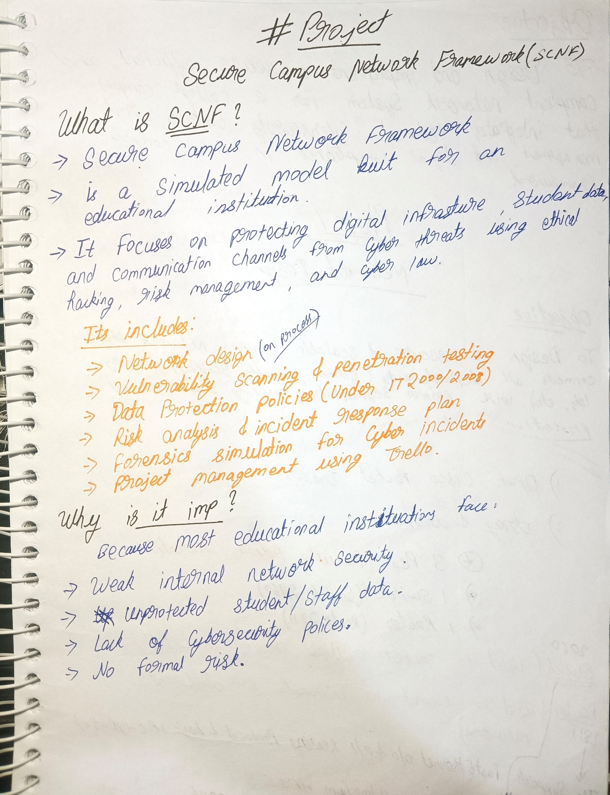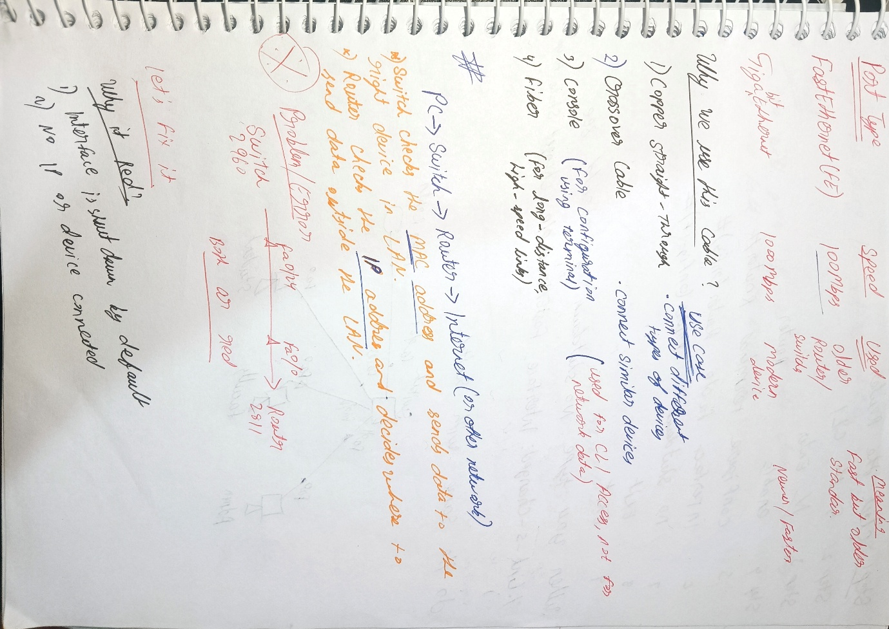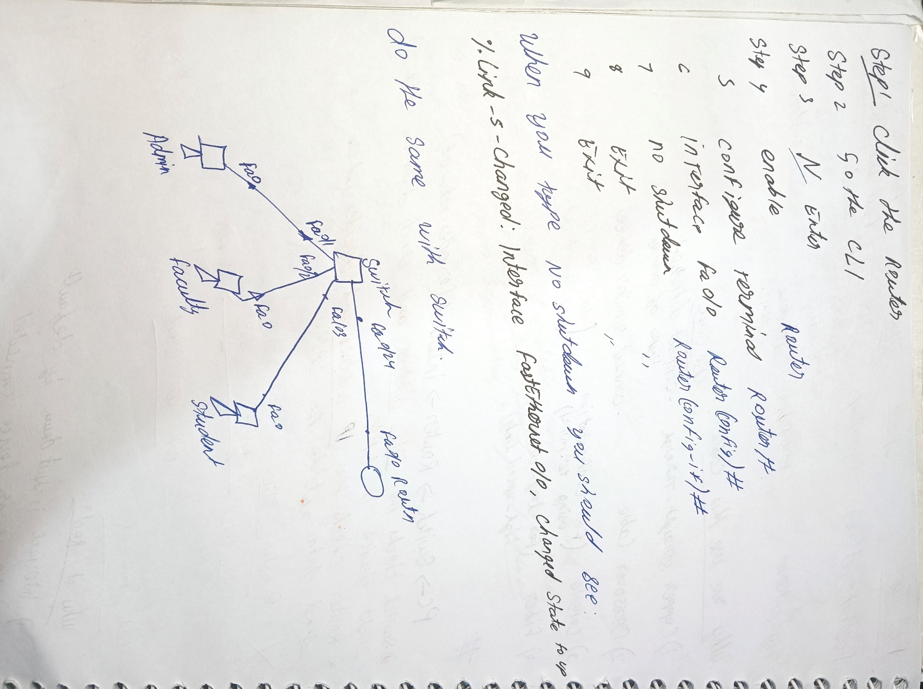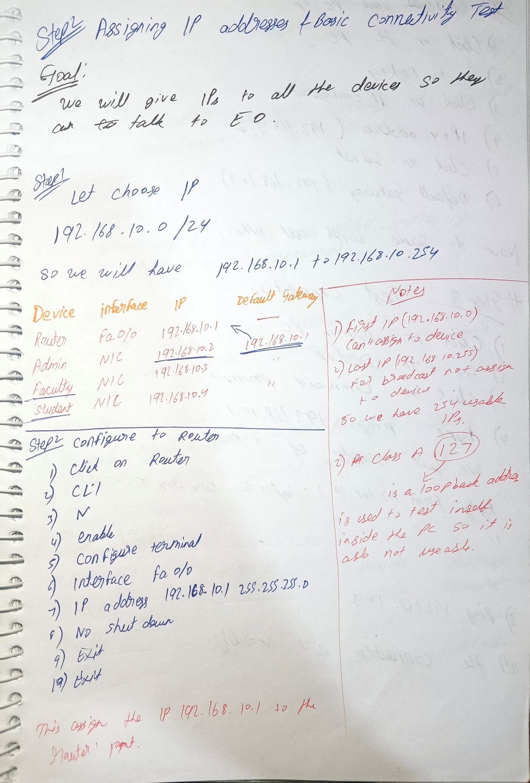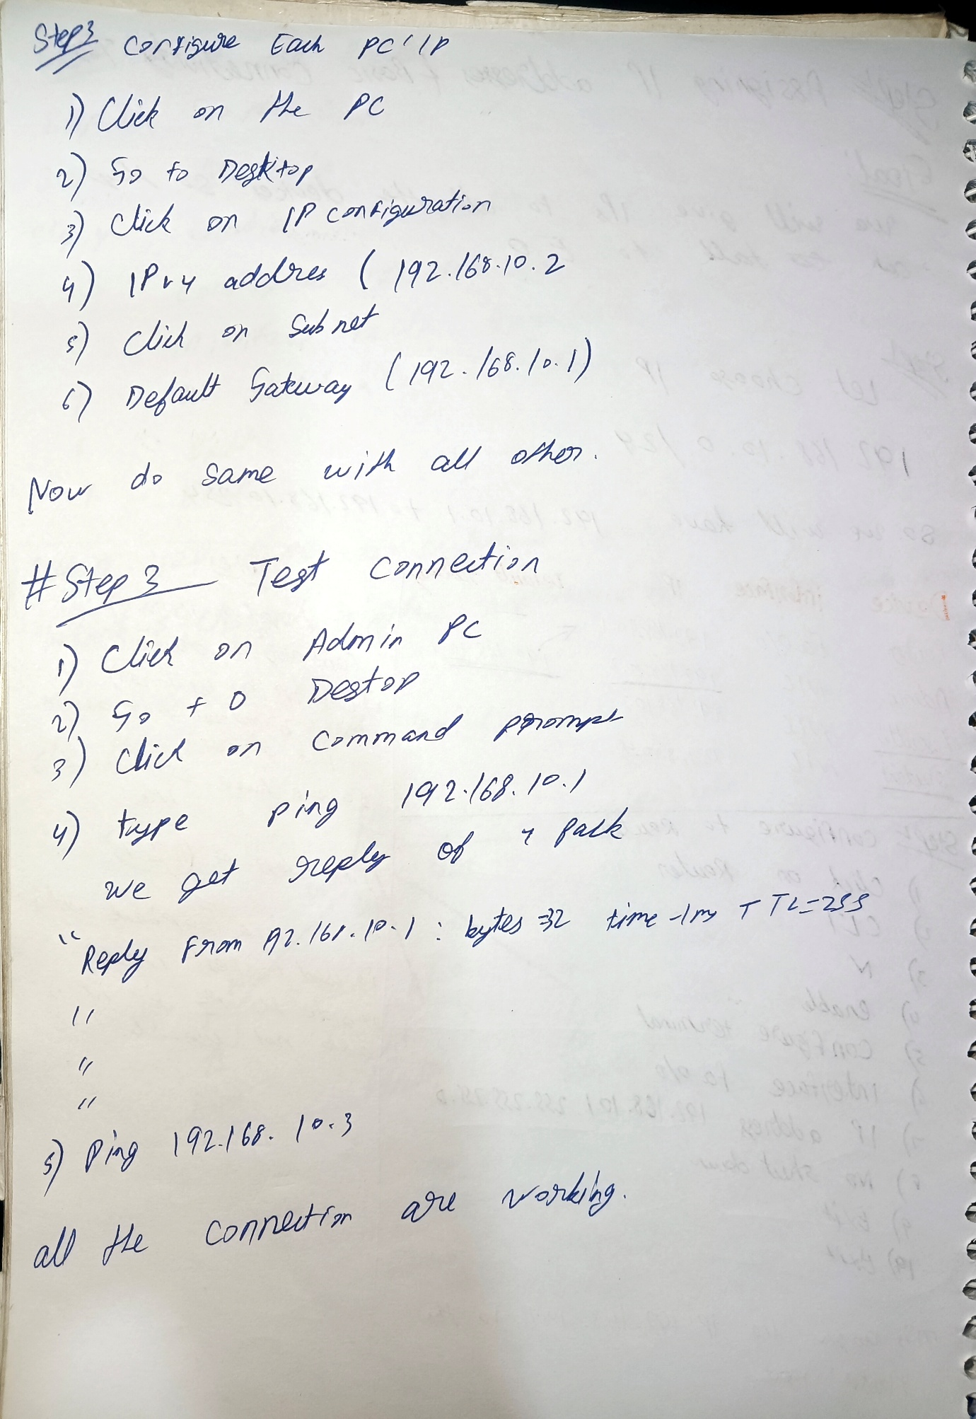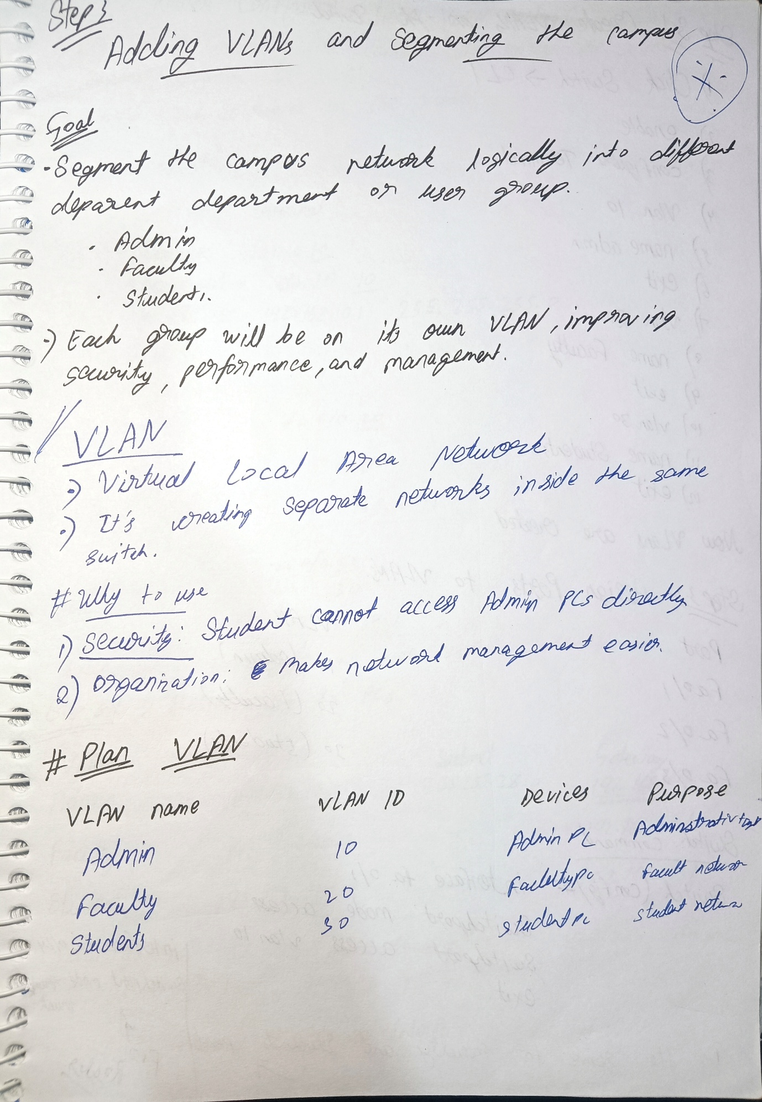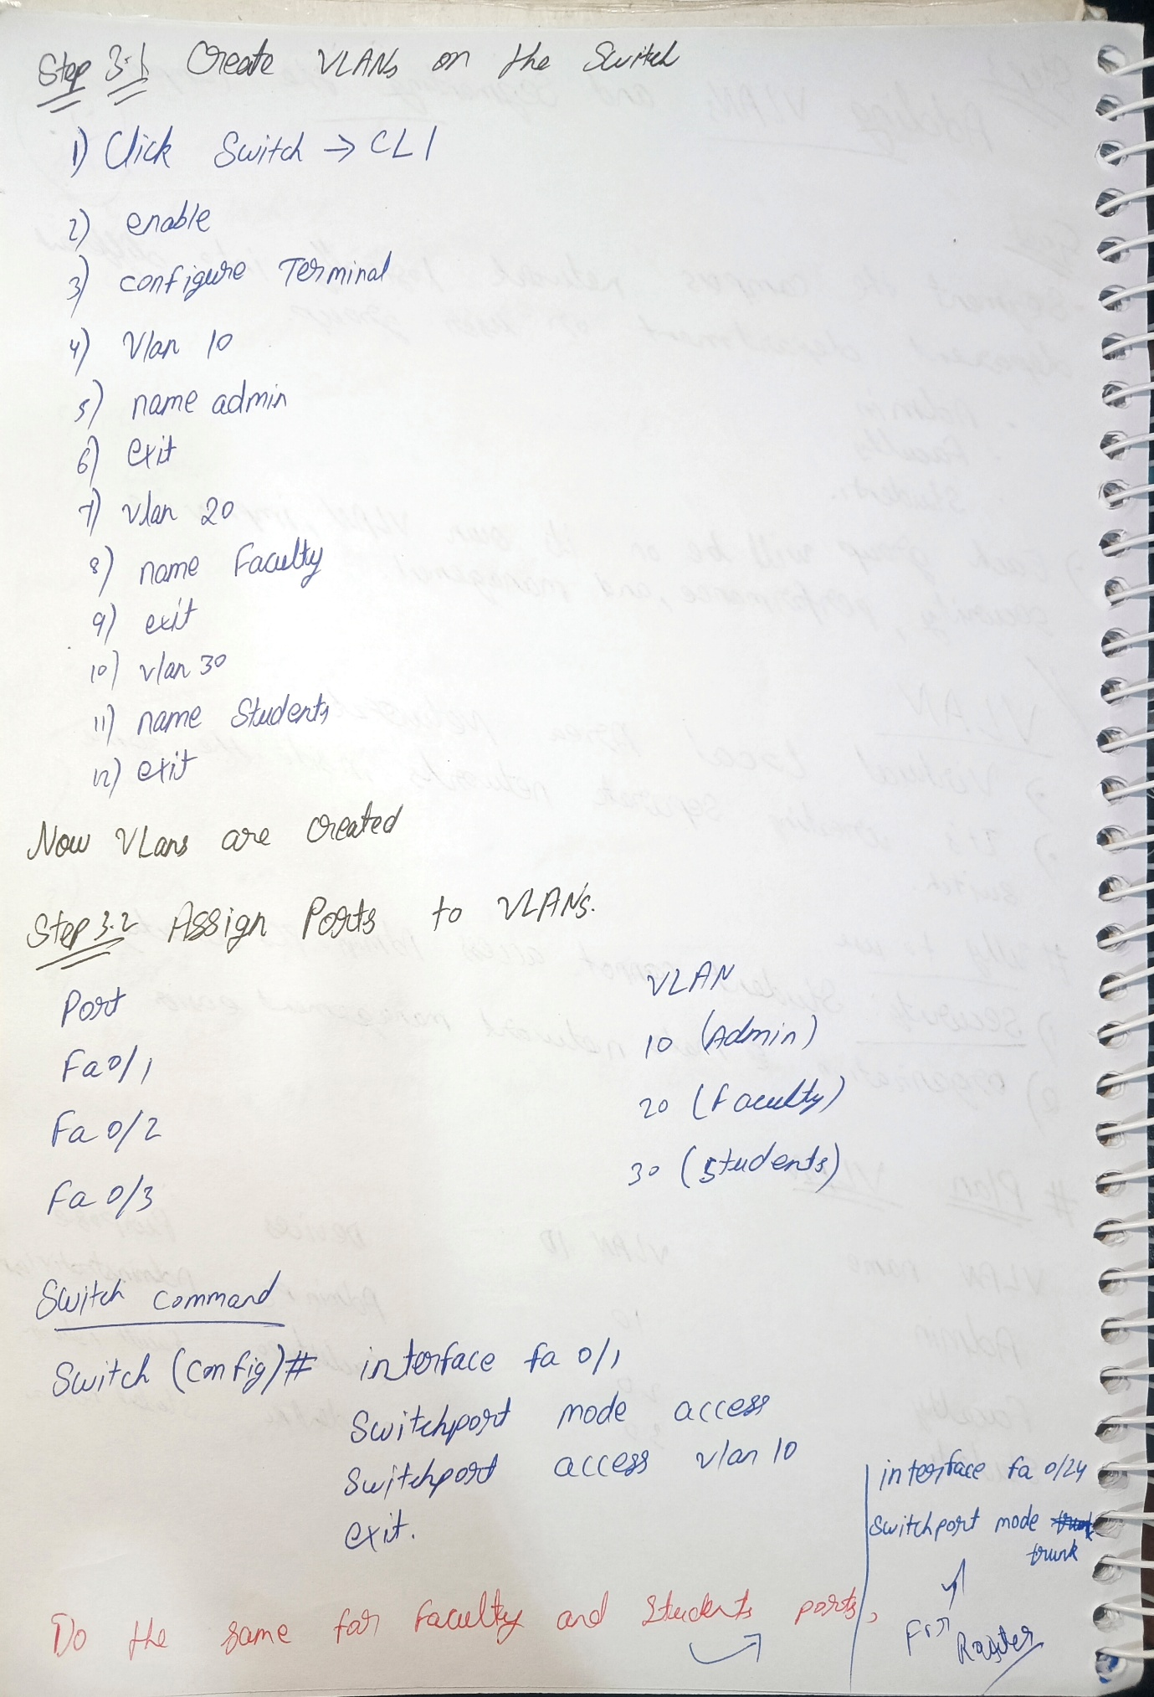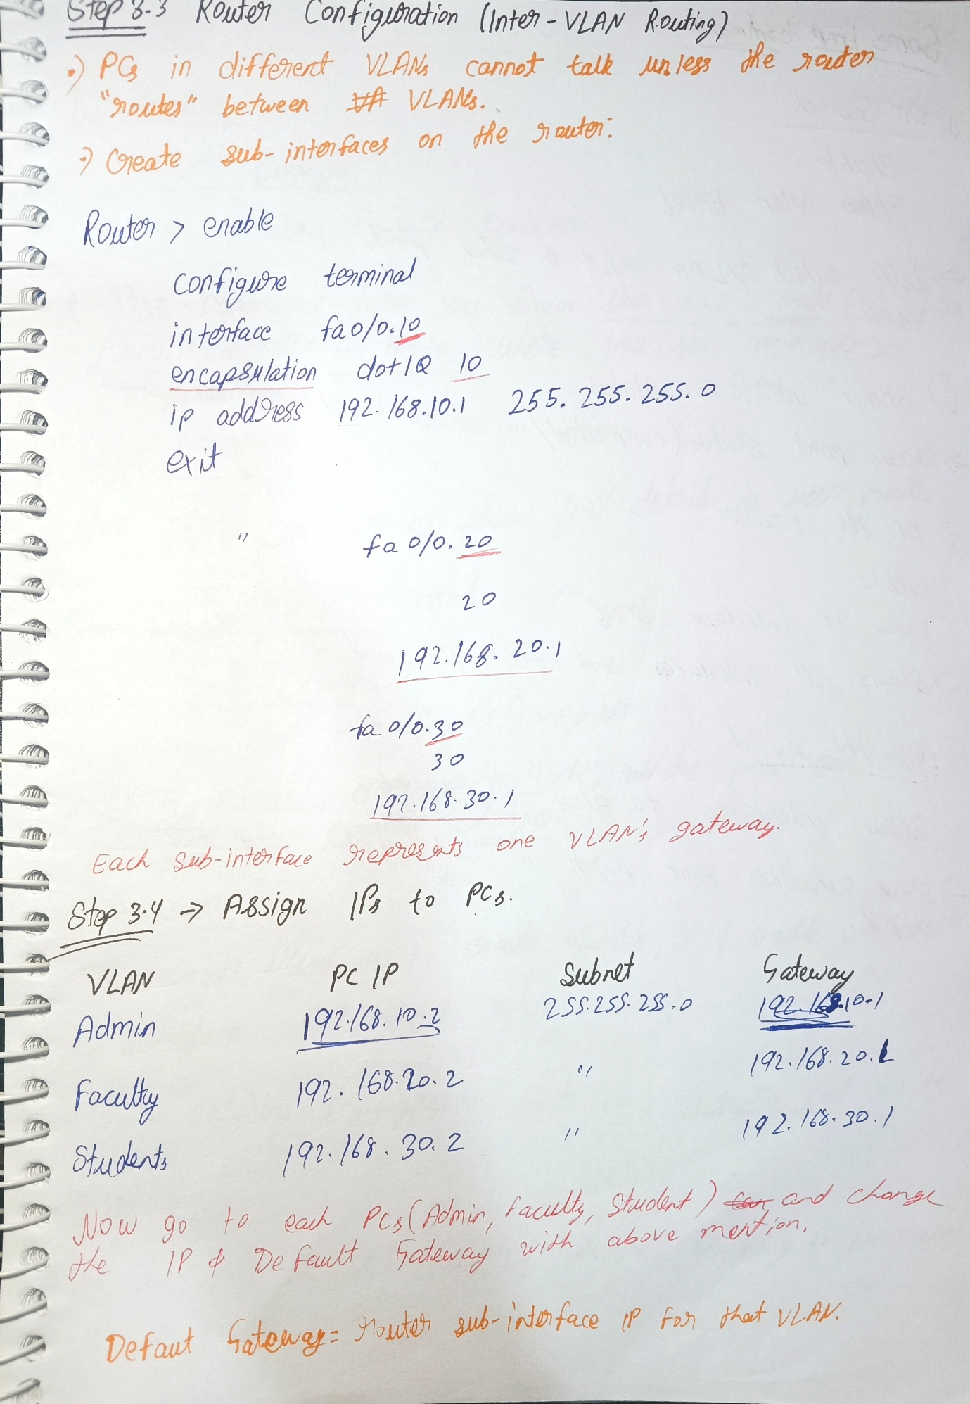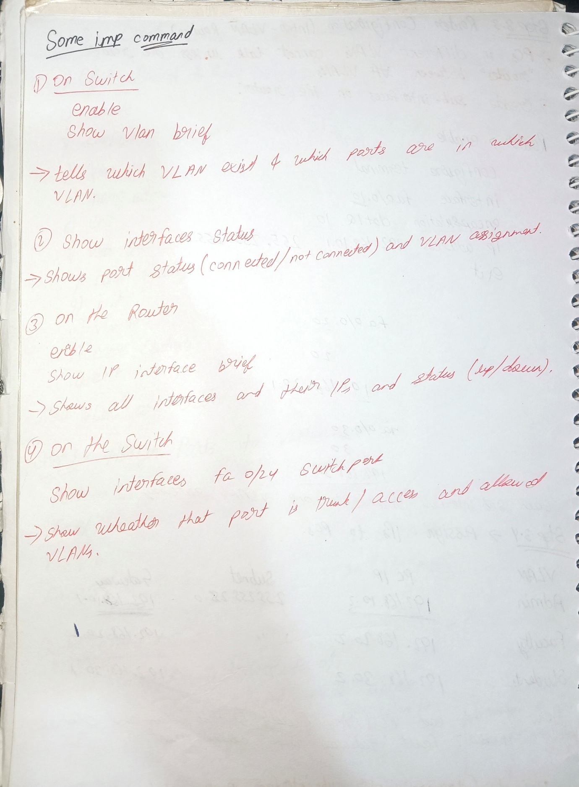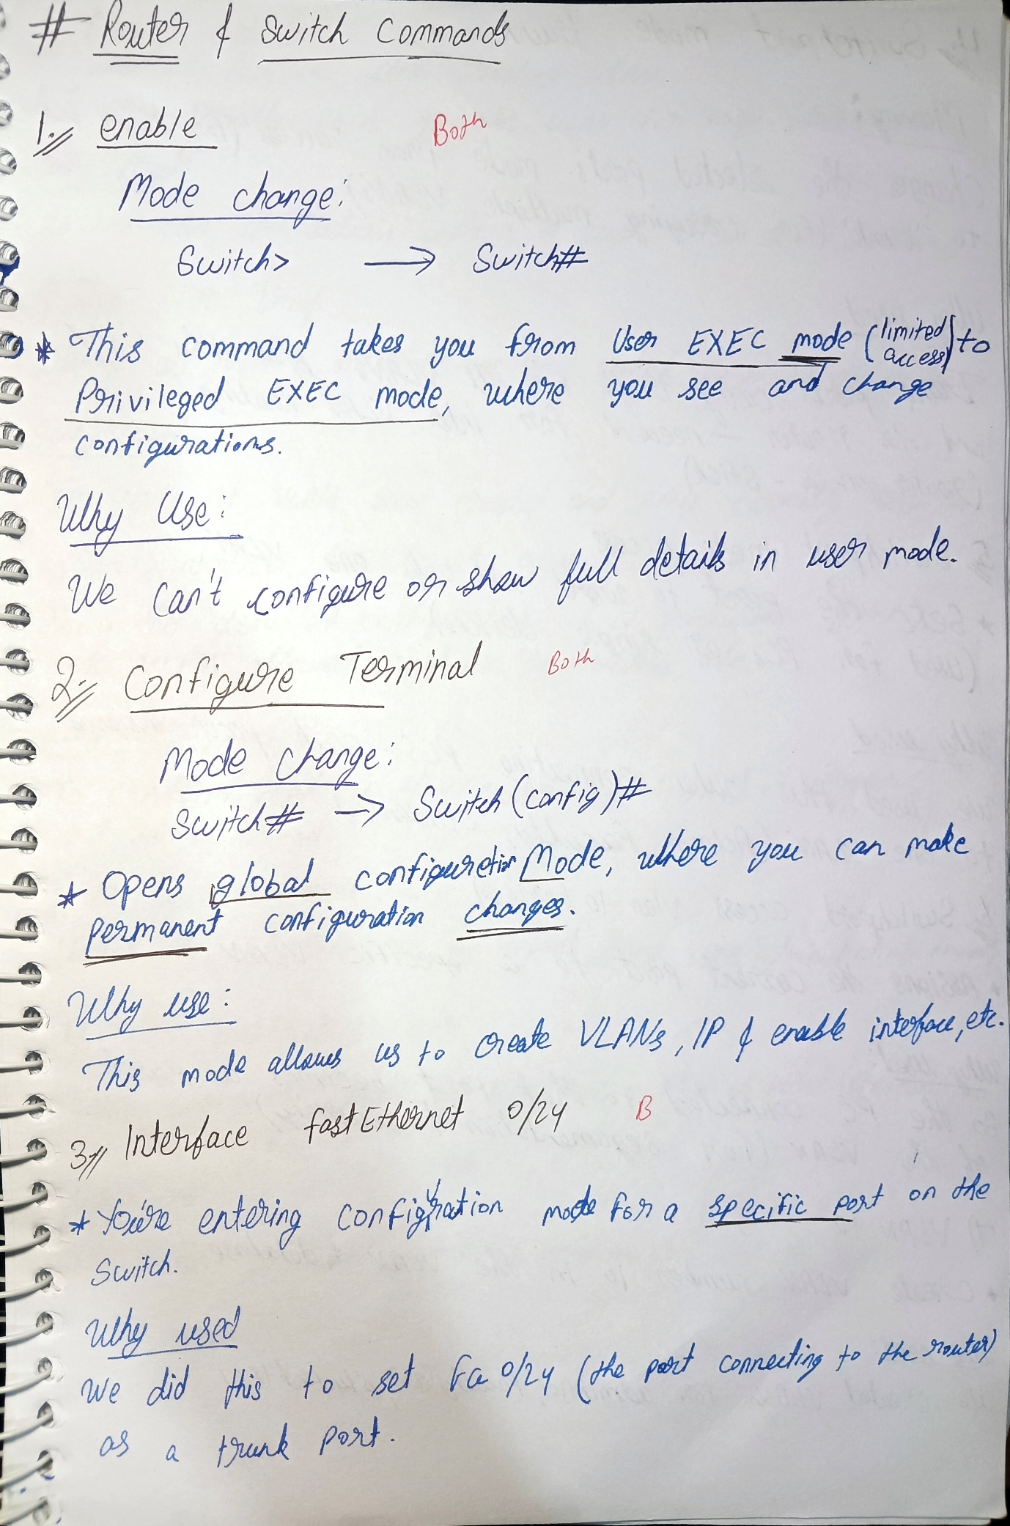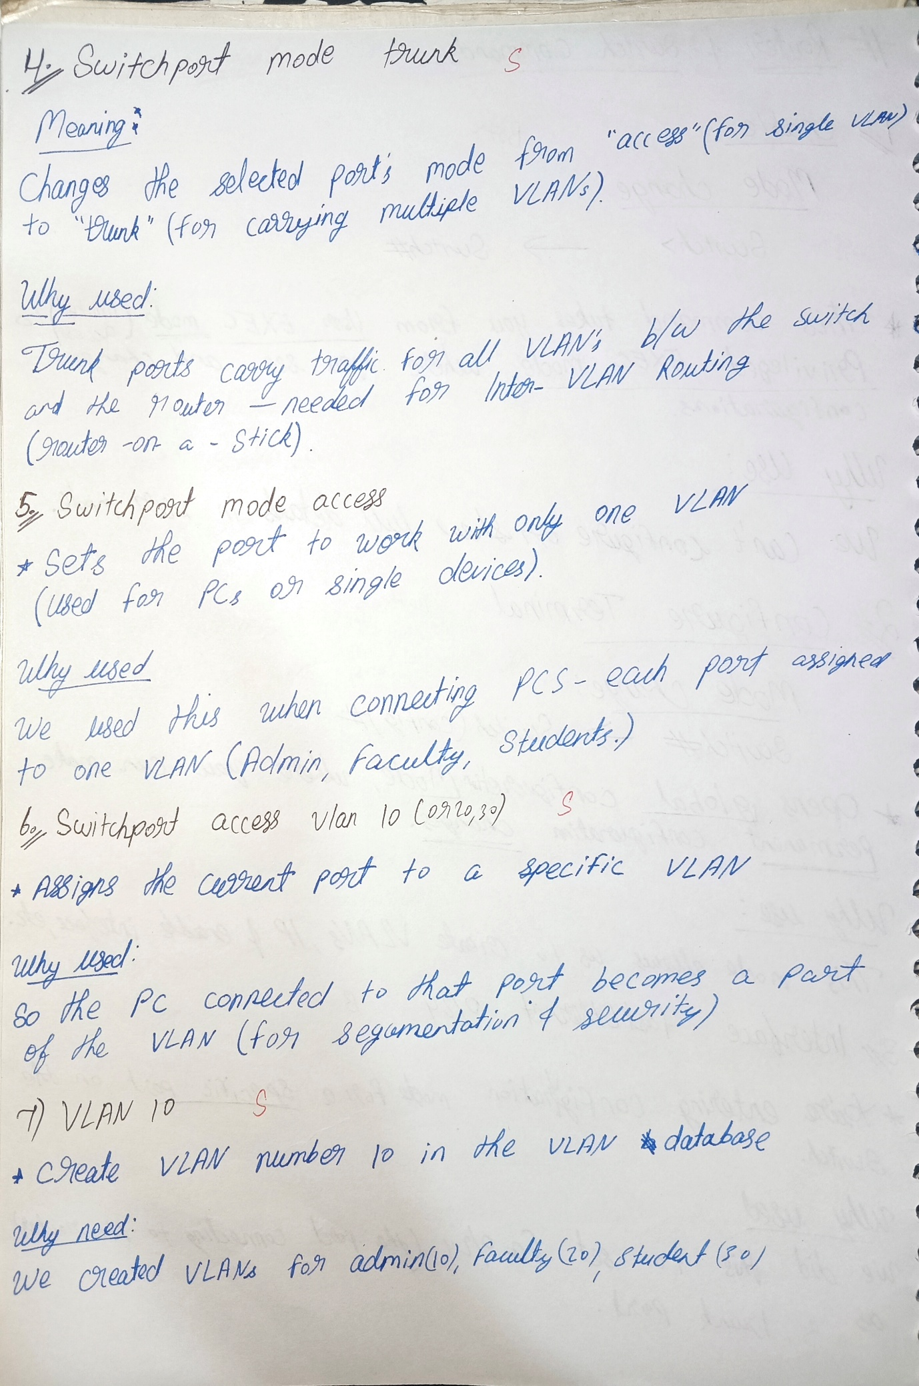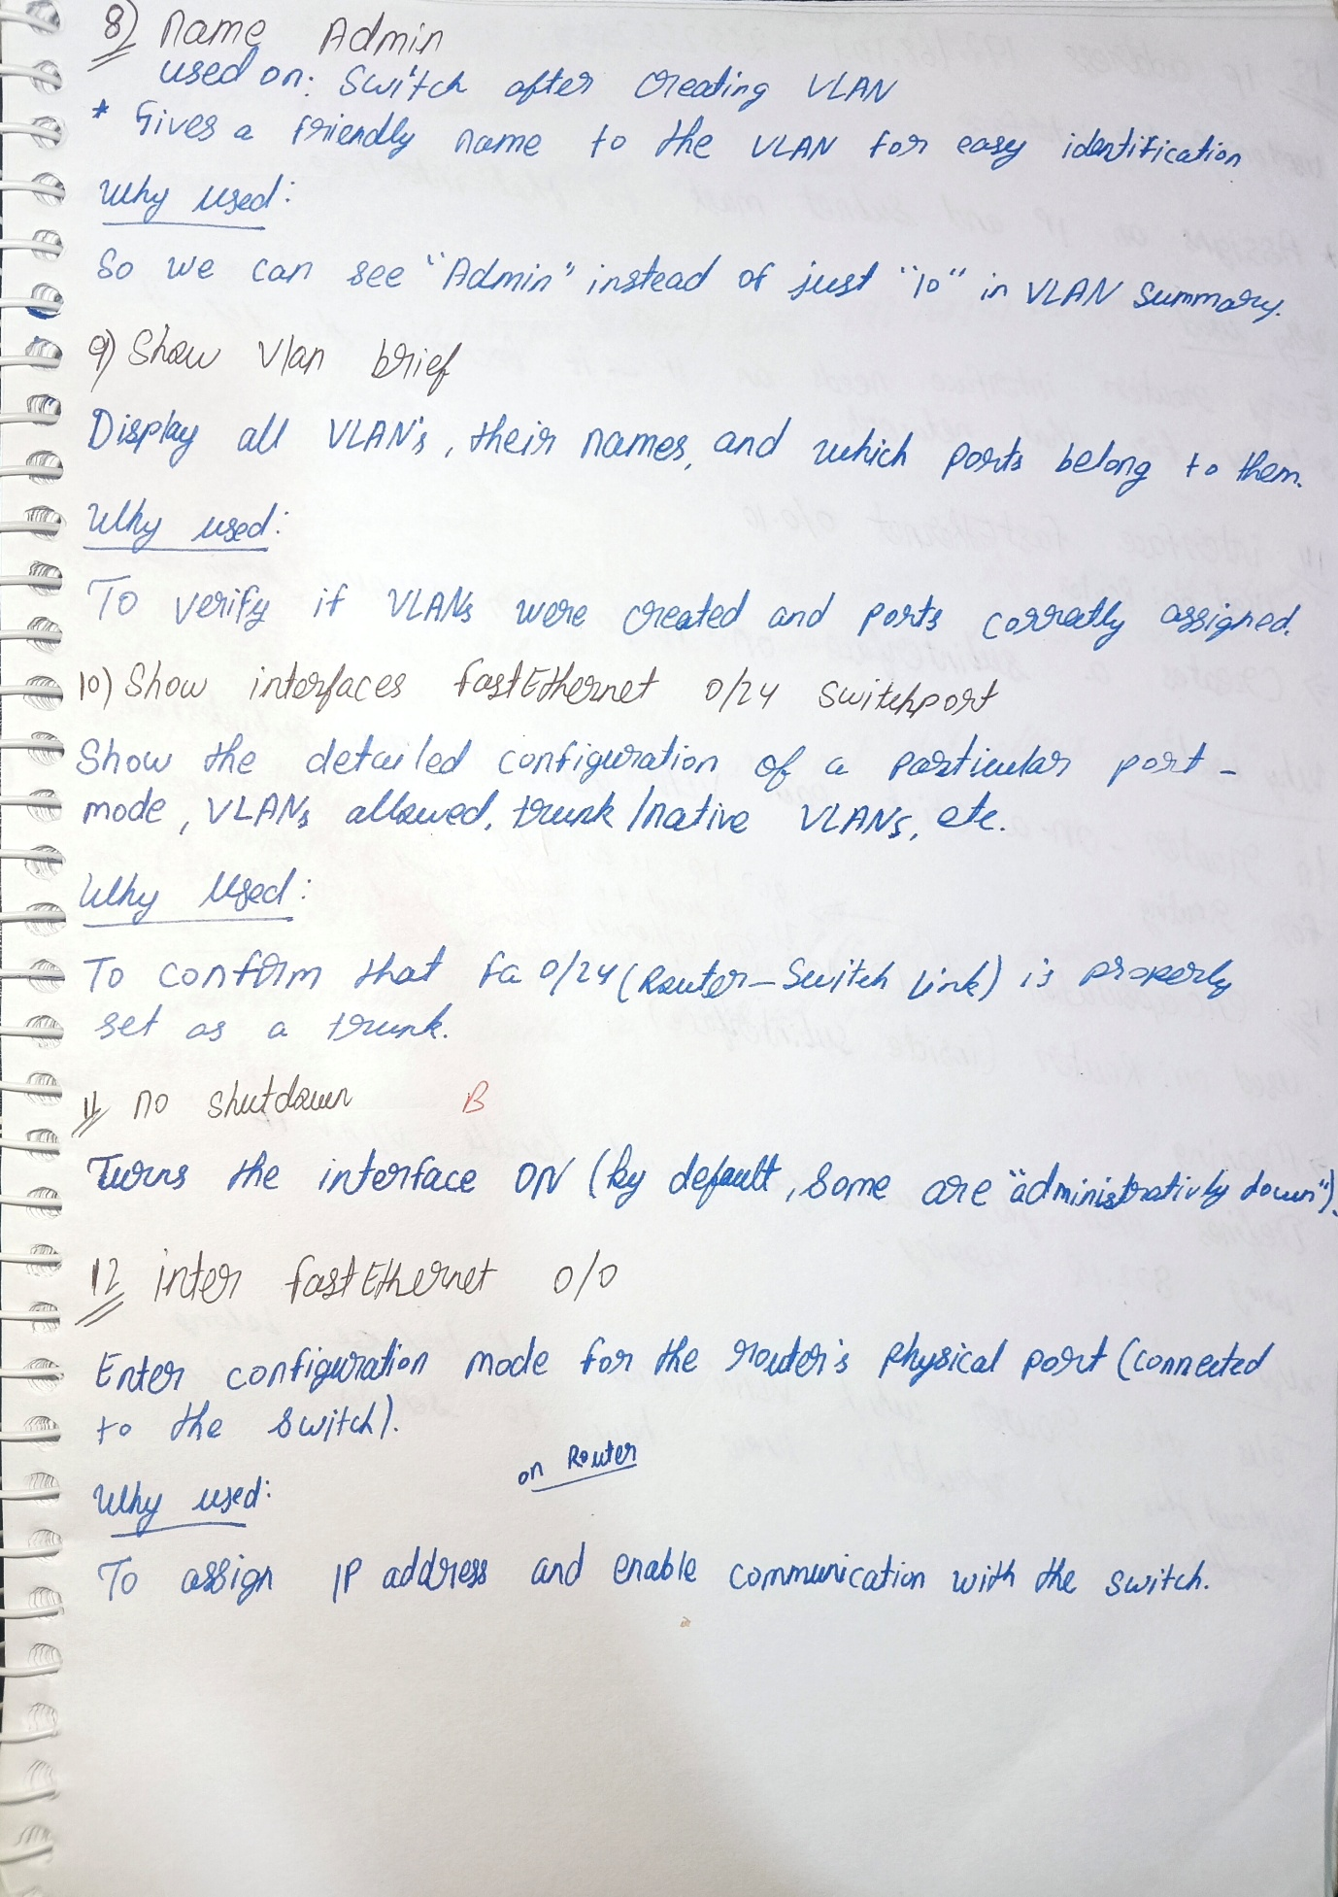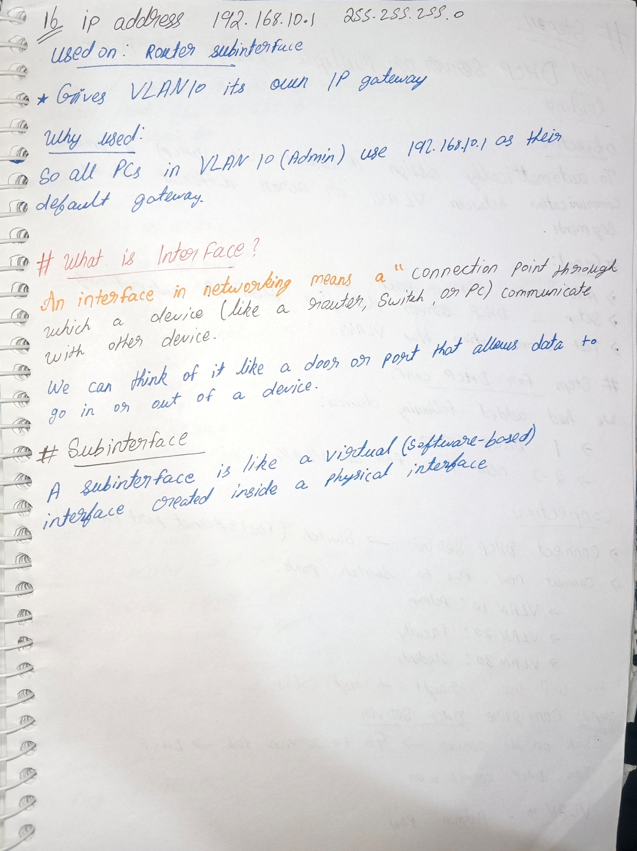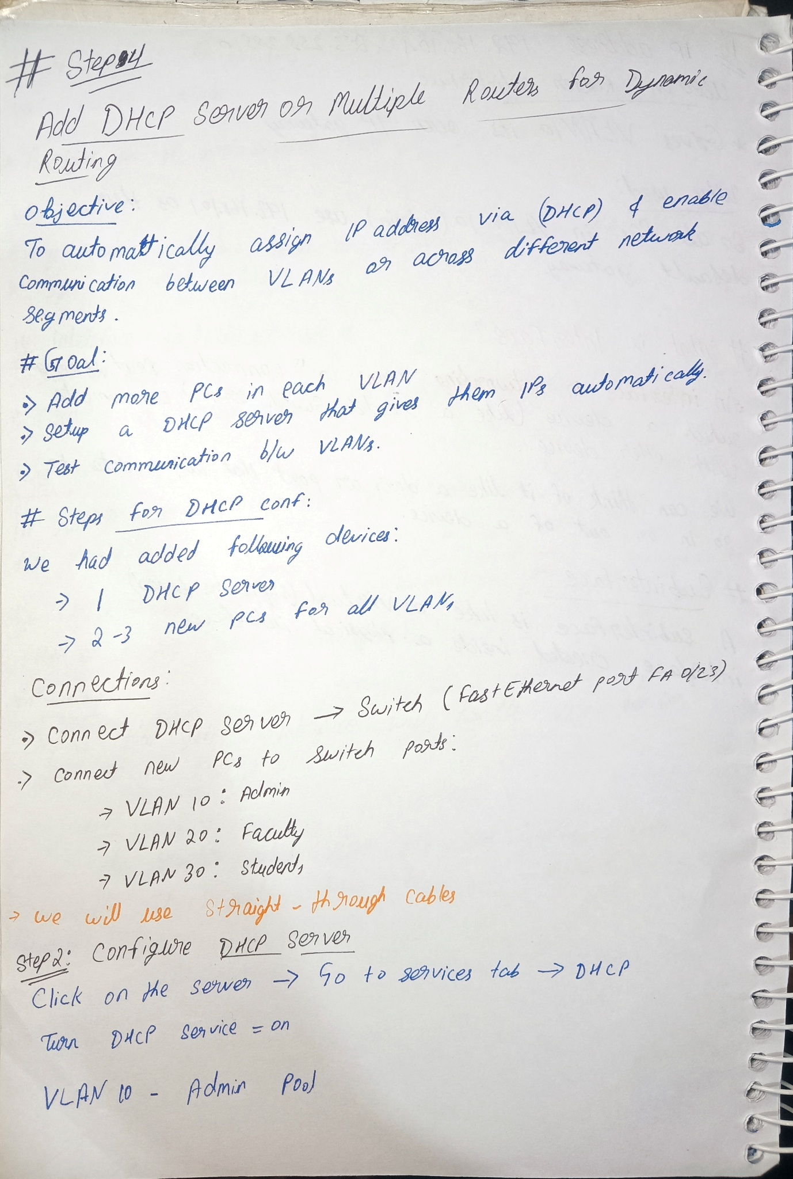

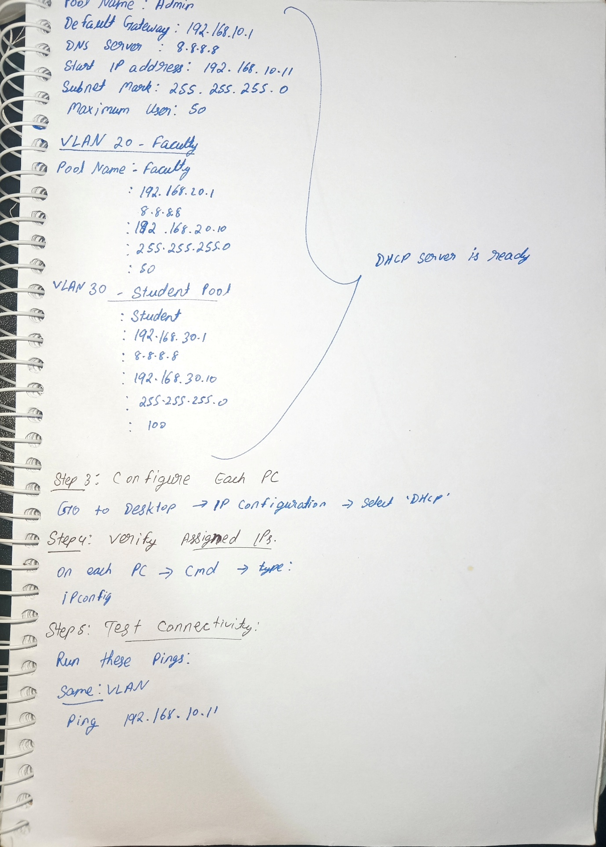

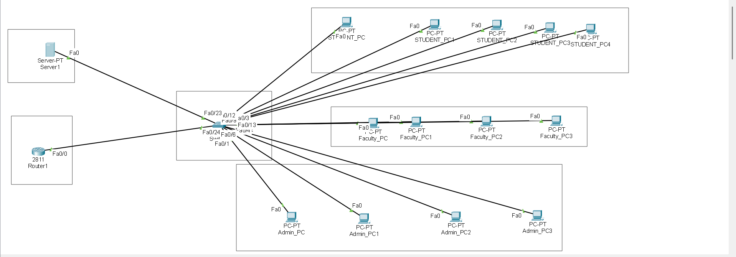

Ethical Hacking Simulation and Analysis

# Introduction to Ethical Hacking

Ethical hacking is the process of identifying vulnerabilities in a system in a controlled and authorized manner. In this project, ethical hacking techniques were simulated to analyze possible security threats to the Secure Campus Network Framework (SCNF).

# Attacker & Target Assumption

In this project, ethical hacking was performed in a controlled laboratory environment. Kali Linux was used as the attacker machine, and a vulnerable test server (Metasploitable2) was used as the target system. The results obtained from this simulation were logically mapped to the campus network designed in Cisco Packet Tracer.

# ***Reconnaissance Phase (Nmap)***

The reconnaissance phase was performed using the Nmap tool. Nmap was used to scan the target system to identify open ports and running services. The scan revealed multiple open ports such as FTP, SSH, and HTTP, indicating potential attack surfaces.

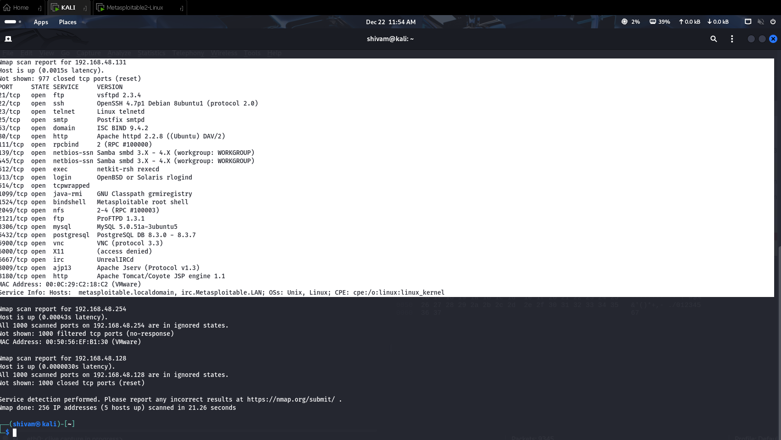

This screenshot shows the result of an Nmap scan performed on the target system. Nmap detected multiple open ports and running services such as FTP, SSH, Telnet, HTTP, MySQL, and Samba. The presence of many open ports increases the attack surface of the system. This scan represents the reconnaissance phase of ethical hacking, where attackers gather information about the target.

# Vulnerability Scanning (Nikto)

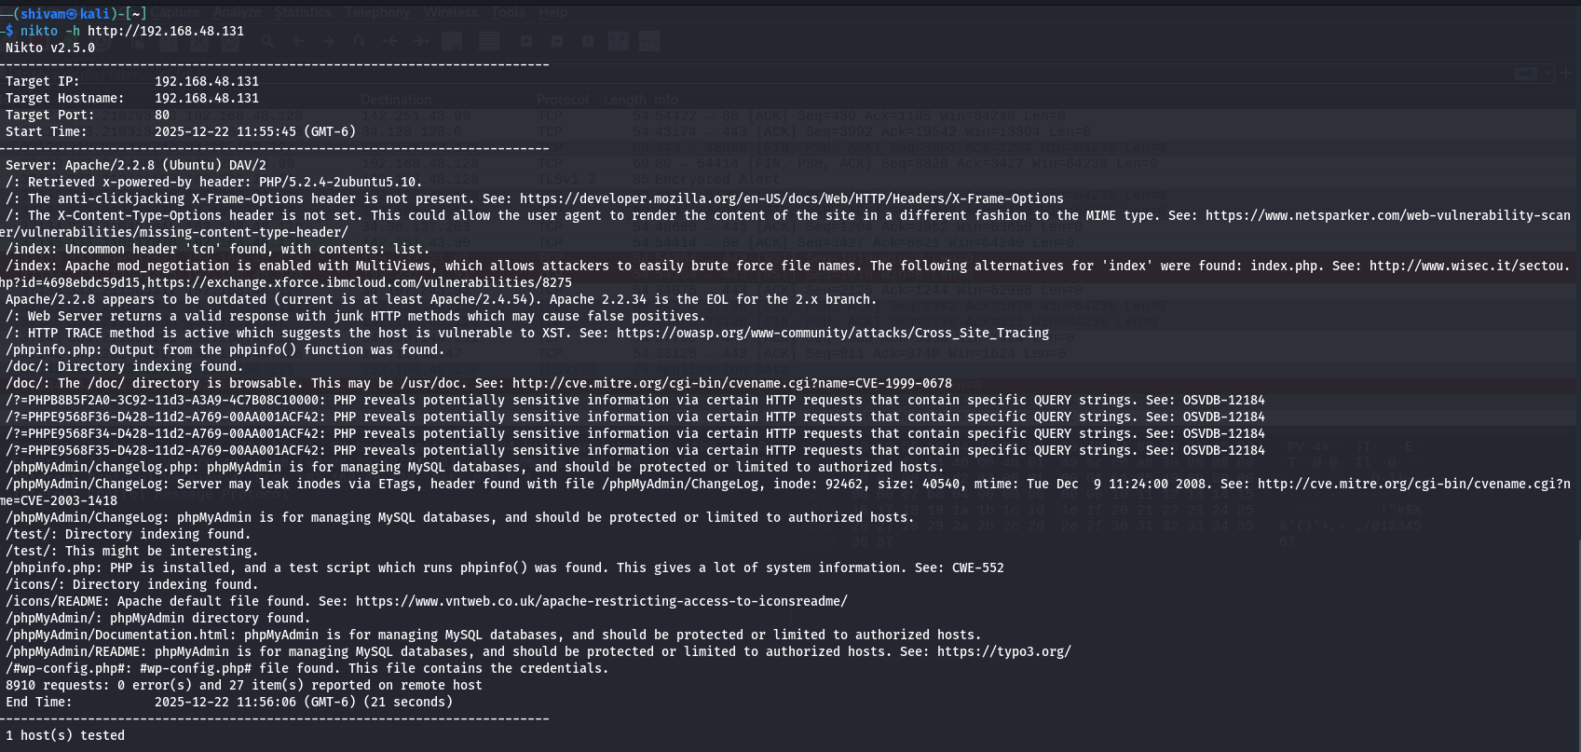After reconnaissance, vulnerability scanning was conducted using the Nikto tool. Nikto helped in identifying web server misconfigurations, outdated software versions, and insecure settings that could be exploited by attackers.

This screenshot shows the output of the Nikto web vulnerability scanner. Nikto identified several issues such as outdated Apache server version, directory indexing enabled, presence of sensitive files, and exposed PHP information. These findings indicate poor server hardening and misconfiguration, which can be exploited by attackers if not properly secured.

# Exploitation Demonstration (Metasploit)

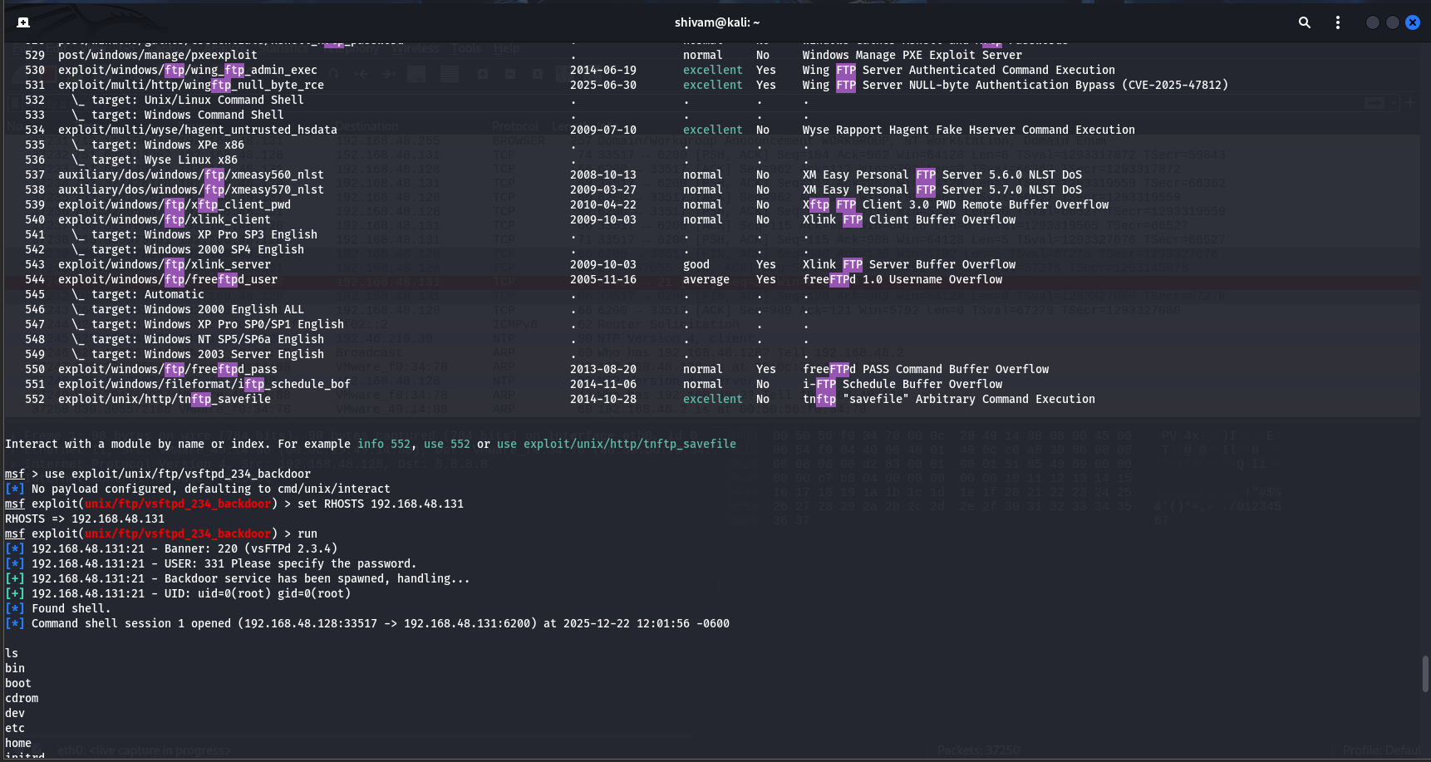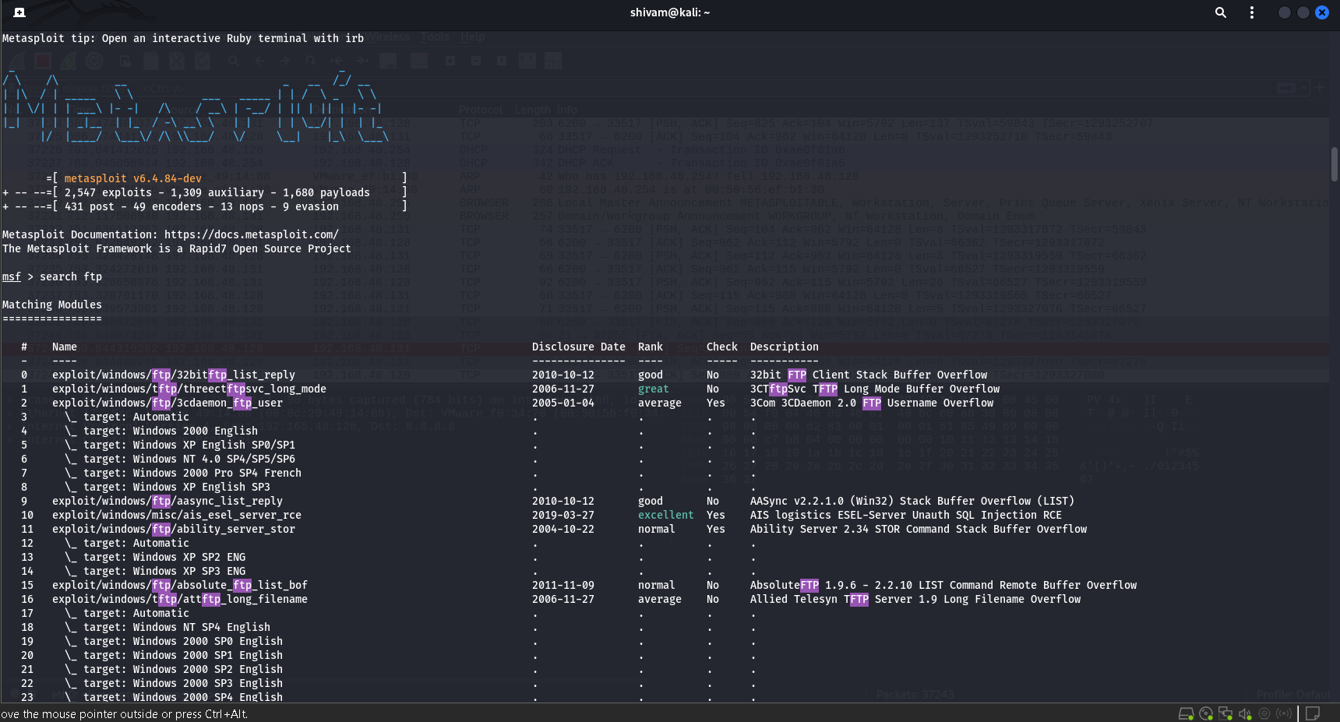A controlled exploitation demonstration was performed using the Metasploit framework to understand how weak services can be exploited. This demonstration was conducted only for academic and learning purposes.

This screenshot shows the Metasploit Framework running on Kali Linux. The attacker searched for FTP-related exploit modules using Metasploit’s built-in search functionality. The output lists multiple exploit modules related to FTP vulnerabilities. This step represents the vulnerability identification phase, where an attacker searches for known exploits based on detected services.

# Traffic Analysis (Wireshark)

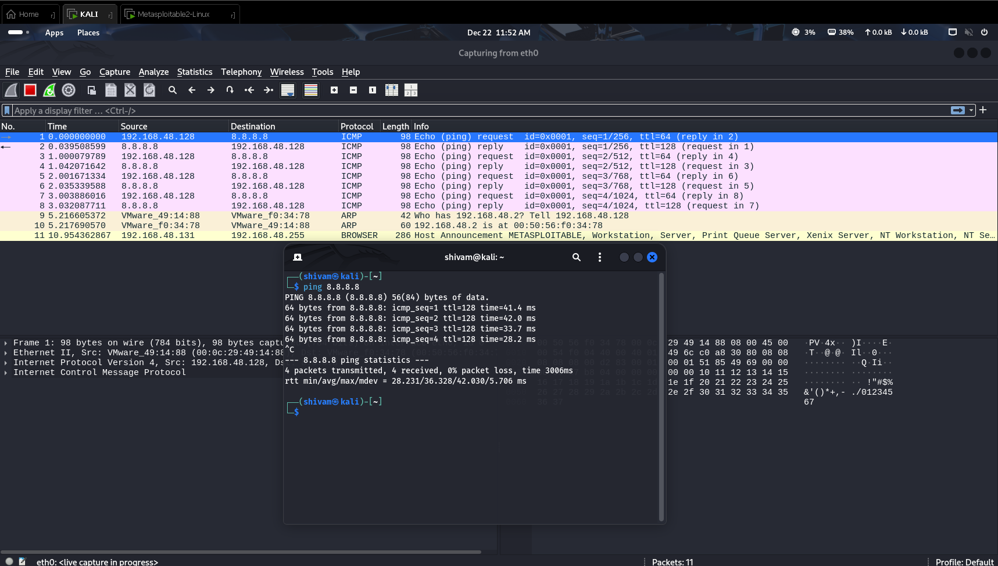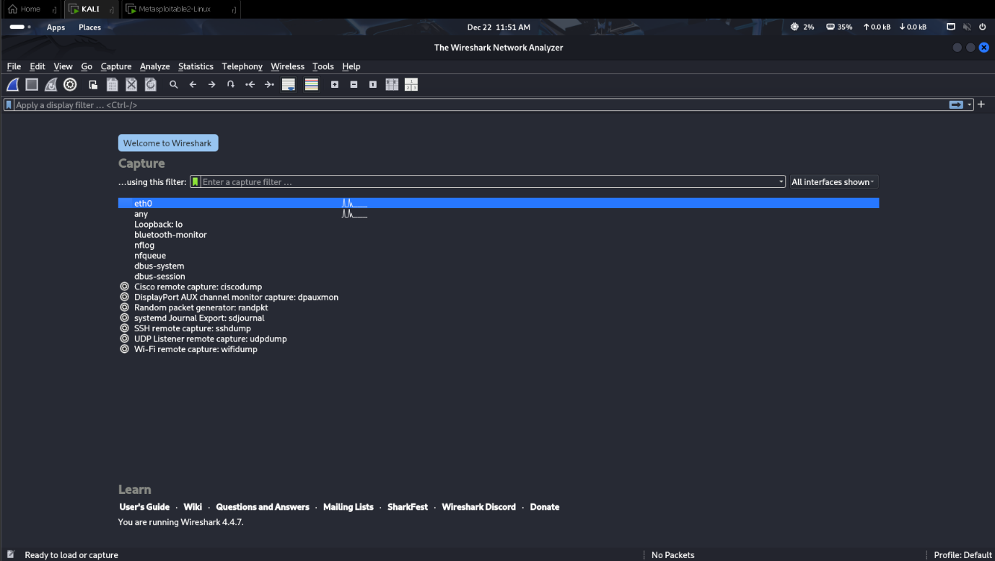Network traffic was captured and analyzed using Wireshark. This helped in understanding how unencrypted data packets can be intercepted during communication. The analysis highlights the importance of encryption and secure network design.

TARGET

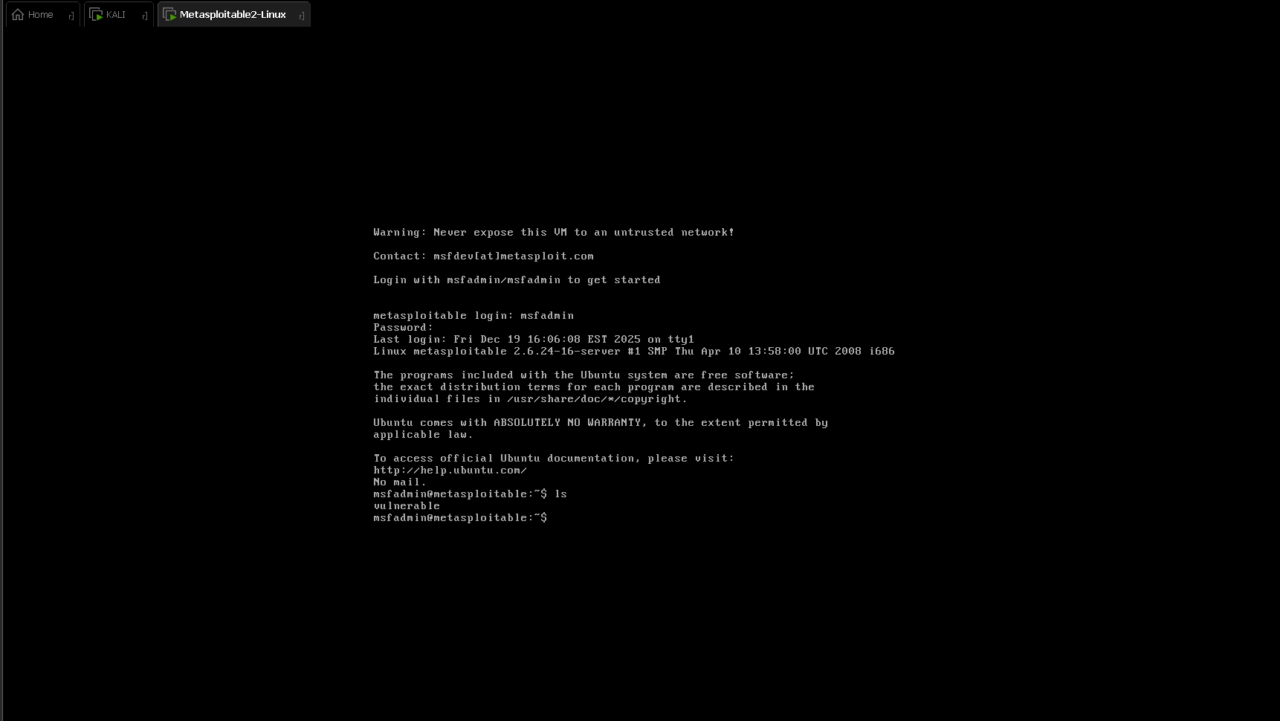

This screenshot shows the Metasploitable2 Linux system, which is an intentionally vulnerable virtual machine used only for learning and ethical hacking practice. The warning message clearly states that this system should never be exposed to an untrusted network. The successful login using default credentials demonstrates weak authentication, which is a common security issue in poorly configured servers. This system is used as a target machine to safely demonstrate attacks in a controlled environment.

Application of Software Project Management (SPM) in SCNF Project

# Introduction

Software Project Management (SPM) plays a crucial role in planning, executing, monitoring, and successfully completing any technical project. In the Secure Campus Network Framework (SCNF) project, SPM principles were applied to ensure proper planning, systematic execution, risk handling, and timely completion of the project.

**Project Planning and Scope Definition**

At the initial stage, the scope of the SCNF project was clearly defined. The project goal was to design a secure campus network using VLANs, DHCP, inter-VLAN routing, security controls, and ethical hacking simulation. Defining the scope helped avoid unnecessary features and ensured focus on syllabus-oriented objectives.

Key activities planned included:

* Campus network design
* VLAN implementation
* IP addressing and DHCP setup
* Security implementation
* Ethical hacking simulation
* Documentation and final submission

**Work Breakdown Structure (WBS)**

The project was divided into smaller and manageable tasks using the concept of Work Breakdown Structure (WBS). Each major activity was broken into sub-tasks such as network planning, configuration, testing, troubleshooting, and documentation. This made the project easier to manage and reduced complexity.

**Scheduling and Time Management**

A week-wise project roadmap was created to schedule tasks properly. The project followed a phased approach:

* Initial planning and design
* Network configuration
* Security implementation
* Ethical hacking simulation
* Documentation and review

This scheduling helped in tracking progress and completing tasks within the given academic timeline.

**Use of Project Management Tools**

Project management tools such as Trello were used to track tasks, monitor progress, and manage deliverables. Tasks were categorized into “To Do”, “In Progress”, and “Completed” stages. This improved visibility of project progress and helped maintain discipline throughout execution.

**Risk Management**

Risk management principles were applied during the project. Possible risks such as misconfiguration, IP conflicts, security loopholes, and time constraints were identified early. Preventive measures like proper testing, VLAN segmentation, ACL implementation, and backup documentation were taken to minimize project risks.

**Quality Management and Testing**

Quality assurance was ensured by continuously testing each module after implementation. Network connectivity, DHCP functionality, inter-VLAN communication, and security rules were tested using ping and traceroute commands. Ethical hacking tools were used to identify vulnerabilities and validate the effectiveness of security controls.

**Monitoring and Control**

Progress was monitored regularly by verifying configurations and testing outputs. Any issues encountered during implementation were resolved using a structured troubleshooting approach. This ensured the project remained aligned with objectives and met quality standards.

**Documentation and Project Closure**

Detailed documentation was prepared throughout the project lifecycle. Hand-written notes, screenshots, configuration outputs, and ethical hacking results were compiled into a structured project report. Final review ensured that all objectives were achieved before submission.

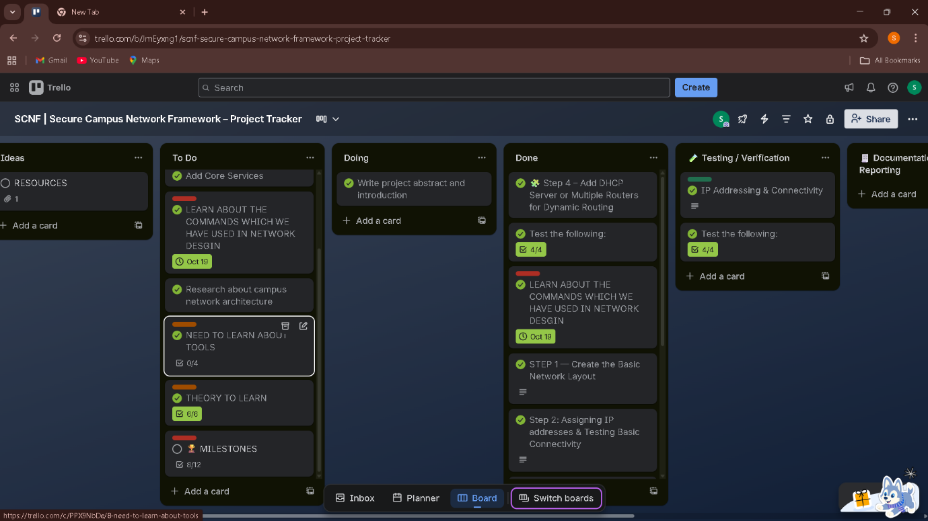

IT Act Sections Applicable to SCNF Project

Section 43 – Unauthorized Access and Damage

This section kicks in when someone gets into a computer system without permission or messes with it.

Simulated Violation:

Ethical hackers showed how easy it was to slip into services like FTP and HTTP on a server with weak security.

Protection Steps:

Split up departments using VLANs

Set up Access Control Lists (ACLs) to block unwanted traffic

Made sure only authorized people could get to the servers

Section 66 – Computer-Related Offenses (Hacking)

Section 66 covers hacking and any shady or dishonest stuff done with computers.

Simulated Violation:

Testers used Metasploit to exploit weak services in a safe, controlled setup.

Protection Steps:

Built a secure network from the ground up

Blocked ports that weren’t needed

Stayed alert about risks from outdated software

Section 43A – Protection of Sensitive Personal Data

This part says organizations have to use reasonable security measures to guard sensitive personal data.

Risk Found:

Sensitive info was exposed because the server wasn’t set up right.

Compliance Steps:

Kept the server network separated with VLANs

Used DHCP with strict IP allocation

Locked down access to admin resources

Section 72 – Breach of Confidentiality and Privacy

Section 72 deals with leaking confidential info without permission.

Risk Found:

Packet captures revealed how easy it is to grab unencrypted data.

Protection Steps:

Segmented the network

Pushed for encryption and secure protocols

Kept admin access under tight control

IT Act Rules and Responsibilities

The IT Act puts responsibility on network admins to keep systems secure. Organizations need to follow good security practices. If they slack off and something goes wrong, there are penalties.

On the SCNF project, the network admin role meant:

Setting up strong access controls

Monitoring the network

Regular risk checks and fixing weak spots

How the IT Act Protects the Campus Network

The IT Act:

Gives legal backup against cyber attacks

Sets penalties for unauthorized access and stealing data

Lays out rules for data protection and system security

Makes system owners and admins accountable

By sticking to these IT Act principles, the SCNF network stays secure and legally compliant.

Conclusion

The Secure Campus Network Framework (SCNF) project brought a secure, scalable campus network to life. We didn’t just sketch out ideas — we actually built and tested a system that kept things organized and protected. VLAN segmentation, DHCP automation, and inter-VLAN routing did the heavy lifting, letting us split up departments logically while keeping communication smooth.

We locked things down further with Access Control Lists, making sure only the right people could move between network segments. Then came the real test: ethical hacking. We ran Nmap, Nikto, Metasploit, and Wireshark in a controlled setup, poking around for weak spots. Whatever we found, we mapped back to our campus network to get a clear picture of the risks and figure out how to fix them.

Throughout, we leaned on Software Project Management principles — planning, execution, risk management, testing, and documentation all got their due. We didn’t stop with just the technical side, either. By weaving in compliance with the IT Act, 2000, we made sure the network stood up to both security threats and legal requirements. In the end, SCNF gave us real-world experience with secure network design and hands-on cybersecurity management — not just theory, but practice.

Future Enhancements

We can make the Secure Campus Network Framework even stronger by adding some advanced security and management features. Think about bringing in a dedicated firewall and an Intrusion Detection/Prevention System (IDS/IPS) — those tools catch threats early and help the team respond fast. For internet access, use Network Address Translation (NAT) and proxy services to keep things secure.

On top of that, it’s worth setting up centralized authentication, encrypting sensitive data, and rolling out Security Information and Event Management (SIEM) tools for real-time monitoring. Expanding the VLAN architecture also helps when the campus grows. Together, these upgrades make the network tougher, more scalable, and ready for whatever comes next.

Resources, Platforms, and Tools Used

* ChatGPT (Project guidance, step-by-step help, problem solving)
* YouTube (Learning tools and concepts)
  + <https://youtu.be/GH9qn_DBzCk>
  + <https://youtu.be/DD3LopYcOYI>
  + <https://youtu.be/xP0DIBkAPqQ>
  + <https://youtu.be/frUQMHXhnvs>
  + Other related videos
* Trello (Project planning and management)
* Google Search (Concept clarification and reference)
* TryHackMe (Pre-learning of ethical hacking tools and concepts)
* Cisco Packet Tracer
* Kali Linux
* Metasploitable2
* Nmap
* Nikto
* Metasploit Framework
* Wireshark
* Microsoft Word
* Microsoft PowerPoint
* Information Technology Act Reference
  + <https://www.indiacode.nic.in/>